**Exp-2**

**Ramit Bose**

**21BCE1316**

WORK BREAKDOWN STRUCTURE

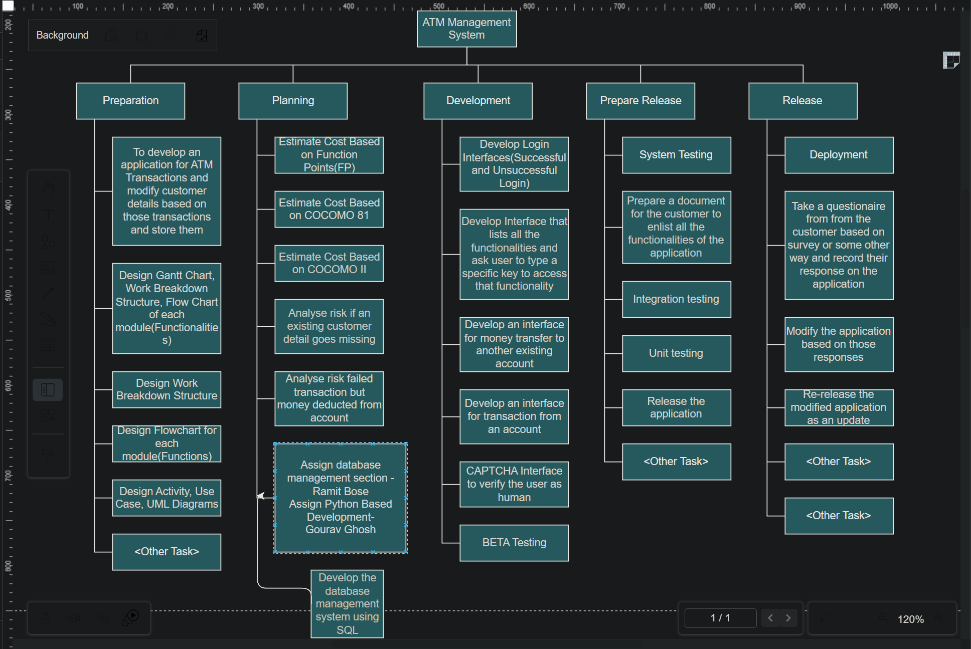

COST ESTIMATION BASED ON COCOMO 81

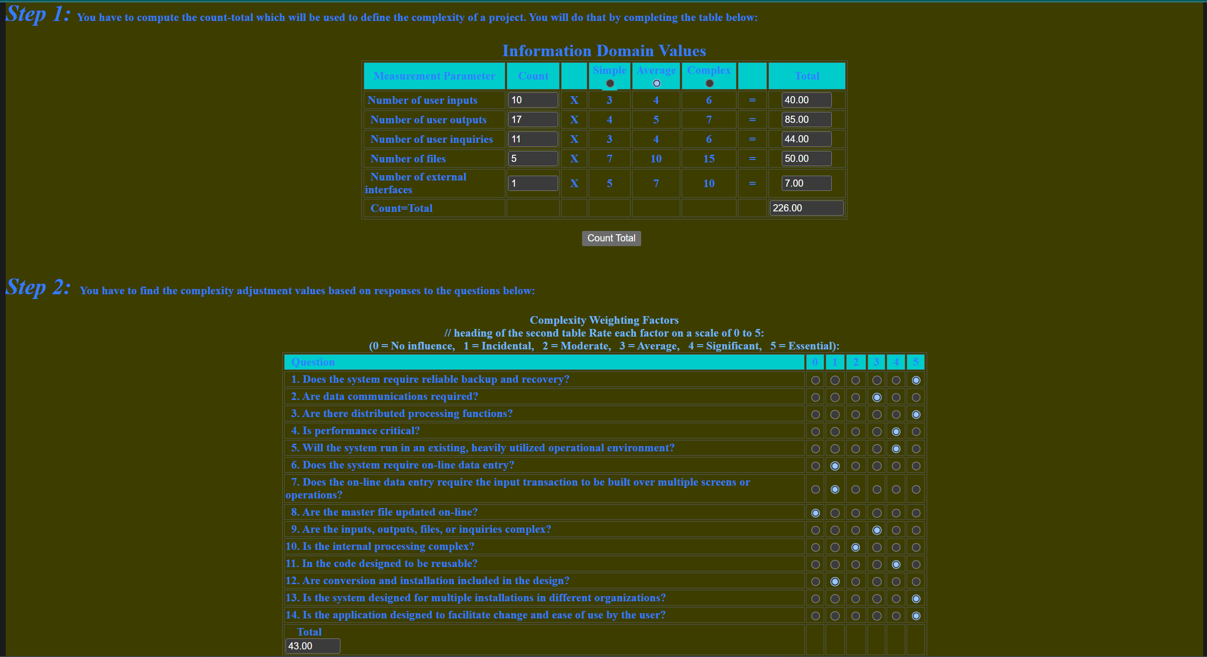

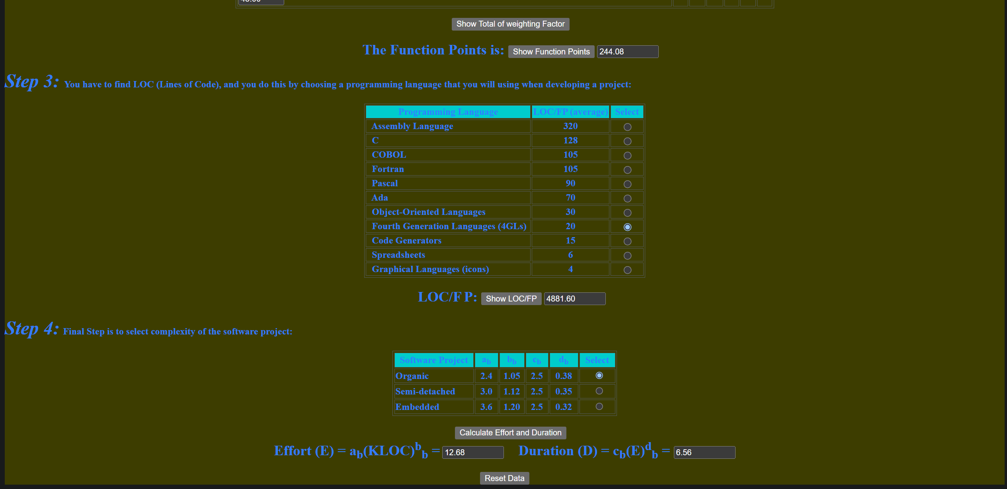

COST ESTIMATION BASED ON FUNCTION POINTS

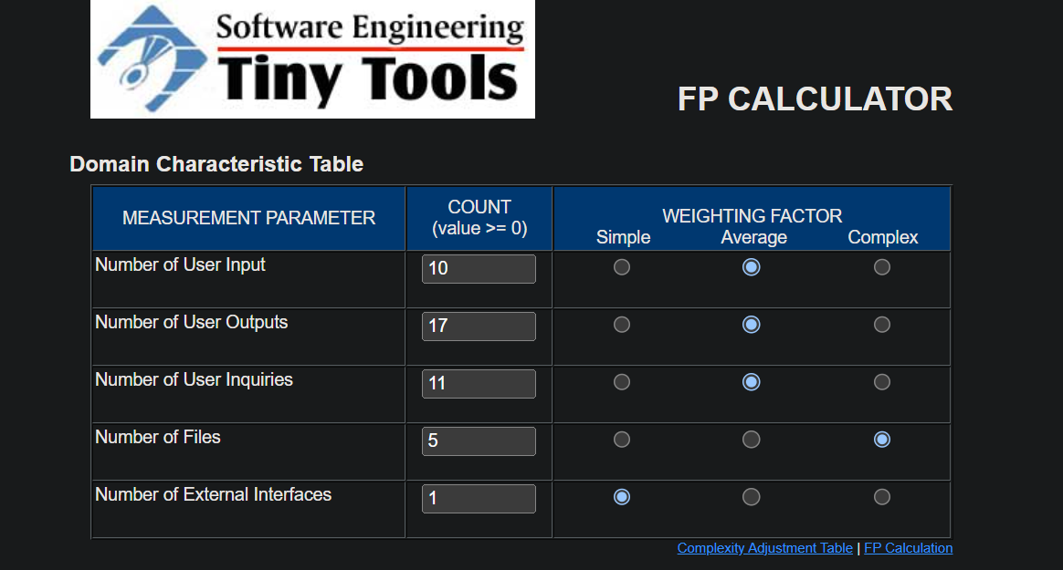

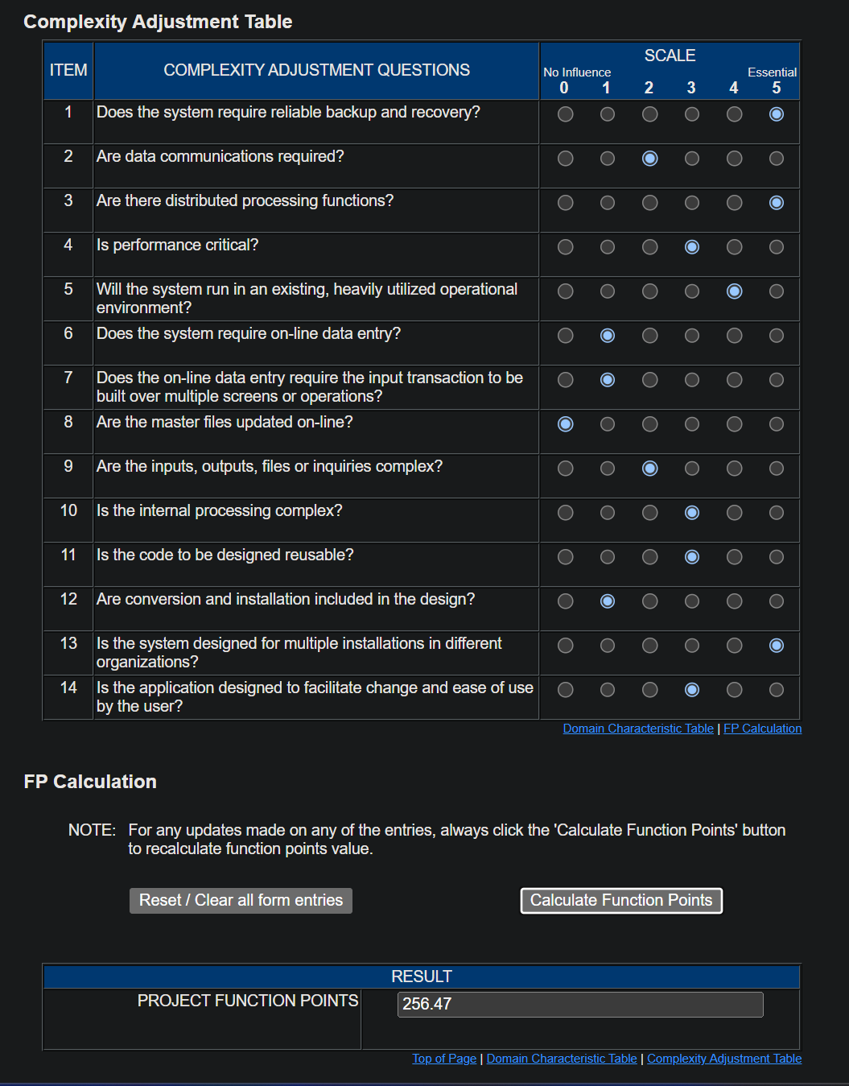

COST ESTIMATION BASED ON COCOMO II

